CTI Clonmel

Raheen College Gaelcholáiste Chéitínn

Code of Positive Behaviour Policy

“Our School Makes all the Difference”

Central Technical Institute Clonmel

Raheen College & Gaelcholáiste Chéitínn

Code of Positive Behaviour

Our Code of Positive Behaviour draws its inspiration and theme from the Irish name Cluain Meala which means the Vale of Honey.

This newly distilled Mission Statement sums up the essence of our Code of Positive Behaviour.
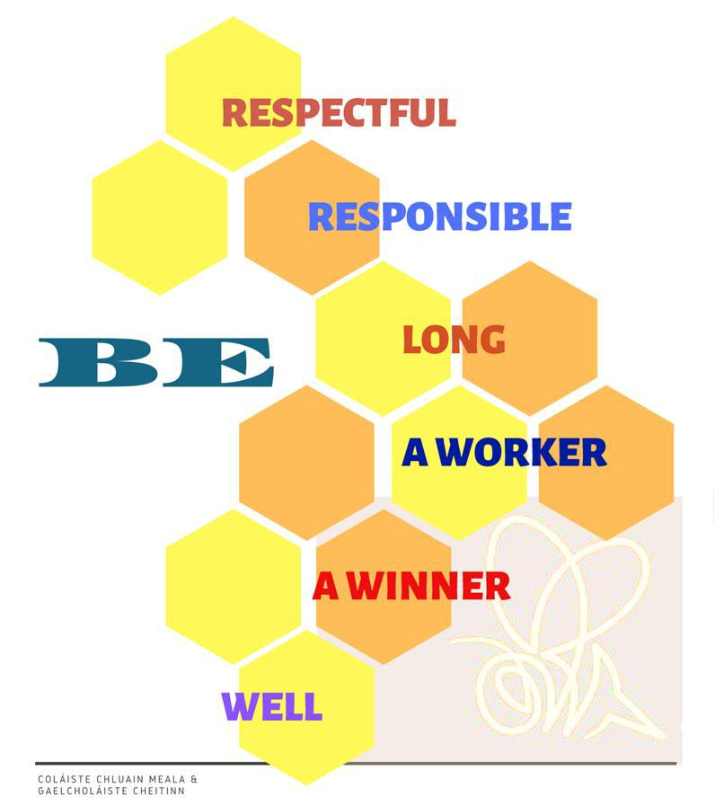

1.0 School Rules

Attendance at any sector of Central Technical Institute, implies that the parents/guardians and the student have read the Code of Behaviour and have confirmed in writing by filling out the school application form, their agreement to the Code of Behaviour, and that they will make every effort to ensure compliance with such code. This written confirmation is the contract between the parent/guardian, student and the school.

1.1 Principles upon which this Policy is based:
Mission Statement of Raheen College & Gaelcholáiste Cheitinn

The role of our school is to facilitate the students and people of Clonmel and its environs in the acquisition of general and specialised education.

We seek:

- To encourage the development of the full person through imparting knowledge and skills, and through inculcating values.

- To develop critical thinking and to promote informed decision-making skills in students.

- To bring students to an awareness of their identity in a multi-denominational and multicultural context.
- To encourage the participation of parents in the education of their children.
- To respond to the educational needs of the local community

In consultation with the students, parents, staff, Principal, Deputy Principal and Board of Management, this mission statement has been distilled so as to be readily understood and embraced by the entire school community.

1.2 Introduction
Rationale for our Code of Positive Behaviour

As part of our ongoing and long standing commitment to improving our school and in compliance with the requirements to do so by National Education Welfare Board we have embarked on reviewing our Code of Behaviour to renew its spirit and to emphasise its positive nature.

The rationale for our school’s Code of Positive Behaviour is to support each member of the school community to take responsibility for his/her own behaviour such that all members of the community can flourish and grow, learn and teach in an environment and atmosphere that is characterised and infused by a spirit of caring, inclusion and friendliness. The emphasis is on positivity since human beings respond best to positive affirmation and are more inclined to be the best they can be as a response to such affirmation. Misbehaviour, then, to a huge extent, is a response to unmet needs and has to be understood in this context. Accordingly, any form of consequences imposed must take this into account.

Education, as we see it, in our school, is everyone’s business as it involves everything that living itself involves. This is the philosophy which governs our Code of Positive Behaviour. This COPB is, therefore, very specific to our school. It distils our Mission Statement, capturing and retaining its essence, to make it accessible to the entire school community. The emphasis of our COPB is on fostering positive student teacher relationships since learning can only take place where such relationships, based on trust, respect and genuine mutuality, exist. Embracing student voice and promoting student well-being, by determining exactly what students expect from us and what we, as school staff, expect from students, is key to the implementation of our COPB and positive classroom behaviour.

To ensure a shared vision of our COPB a handbook for staff, drafted by staff after much discussion, consultation and reflection has been compiled to:

- Emphasise the importance and centrality of good, trusting student teacher relationships.
- Explore positive classroom management strategies.
- Set out positive classrooms rules and expectations
- Raise awareness of maladaptive behaviours
- Highlight positive recognition that students will receive for following the rules
- Outline a Code of Positive Behaviour action plan that students must follow at all times
- Stress the importance of implementing logical consequences when rules are breached

We as a school, believe that logical consequences are based on the assumption that students learn best by experiencing the results of their behaviour. The object of the Positive Code of Behaviour is to guide students towards self-control, towards self-discipline, to help them see what should be done and what should not be done, and finally, towards taking responsibility for whatever choice they make. All logical consequences, accordingly, must be related logically to the misbehaviour, must be respectful of both self and the student while at the same time being both firm and kind. A logical consequence must be reasonable such that it is as logically understandable to the student as it is to the adult.
1.3 Student Well Being
The Be Well Programme

Aligning with our newly distilled Mission Statement our school also implements a wellbeing initiative called “Be Well”. As student wellbeing and behavior are intrinsically linked, this initiative aims to link with our Code of Positive Behaviour. This initiative is designed to help students recognise the indicators of wellbeing; Active, Responsible, Connected, Resilient, Respected and Aware. This programme asks students to:

 |  | Be Well
B | ● | Be your BEST self – by keeping positive
 |  | friendships and relationships.
E | ● | Boost your mood – EXERCISE daily.
W | ● | Value yourself and the WORK you do.
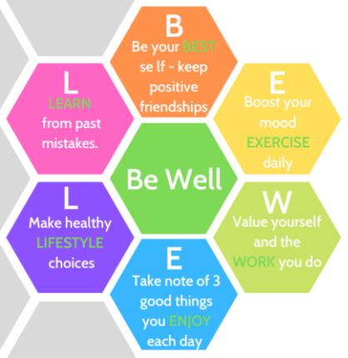

- ● Take note of 3 good things you ENJOY each day.

- ● Make healthy LIFESTYLE choices; eating, sleeping, exercise, peer groups etc.
L ● LEARN from past mistakes.

2.0 School Charter of Rights and Responsibilities

All stakeholders in CTI Clonmel have rights and responsibilities within the school.

2.1 Student Rights and Responsibilities
Student Rights
- To the highest standard of education to meet the individual needs of students.
- To be safe and secure in a non-bullying environment
- To be treated with respect
- To be taught in a clean and orderly environment
- To have access to all areas of the curriculum, subject to available resources
- To have classes start punctually and have lessons that are well prepared
- To be assessed regularly, through homework and tests
- To have access to extra-curricular activities
- To have property treated with respect
- To have a right to be heard and be recognised as active citizens
S
Student Responsibilities
- To be well behaved both inside and outside the school and obey school rules
- To work hard in class and cooperate with the teachers
- To treat everyone with respect
- To work to the best of ability at all homework and assessments

- To arrive punctually, be prepared for class and do nothing to interrupt the teaching of the lesson
- To wear the correct uniform and take care of property
- To aim to take part in extracurricular activities
- To not bully through verbal, text, internet and exclusion
- To use language and materials that are appropriate and inoffensive
- To support the school in implementing the Code of Positive Behaviour
- To attend meetings organised by the school

2.2 Teachers and Staff Rights and Responsibilities
Teachers and Staff Rights

- To work in a clean, attractive and safe environment free from verbal, physical abuse/intimidation
- To be allowed teach without interruption or disruption
- To be kept up to date about changes and developments as they occur
- To have fair and equal access to staff development
- To be treated in a professional manner by all colleagues
- To be supported by management while carrying out their duties
- To be supported in the delivery of the curriculum
- To have adequate resources to deliver the curriculum effectively
- To have adequate time to carry out professional duties
- To have personal welfare issues dealt with in a sensitive and confidential manner
- To have a right to be heard

Teachers and Staff Responsibilities
- To prepare effective teaching resources
- To keep up to date with educational changes and developments
- To treat all students, staff and parents/guardians in a professional manner
- To promote a caring environment for all
- To support management in the implementation of decisions
- To be familiar with and implement school policies

- To create and implement a set of classroom rules in line with the schools Code of Positive Behaviour

- To consistently and fairly implement classroom management strategies outlined with the Teacher Code of Positive Behaviour Handbook
- To support a clean, safe and attractive work environment

2.3 Parents/Guardians Rights and Responsibilities
Parents/Guardians Rights
- To have access to the relevant school policies and guidelines
- To have access to information about their child
- To feel confident in sharing issues or concerns about their child and learning
- To have their child spoken to in a professional and controlled manner
- To participate in the Parents Association
- To have a right to be heard

Parent/Guardians Responsibilities
- To support this code of positive behaviour and all school policies
- To encourage and support their children by showing interest in their work and school life
- To praise your child’s efforts
- To provide space and time for your child to do their homework
- To support the wearing of the school uniform
- To keep up to date with the school journal
- To monitor your child’s use of mobile phones, the internet and all social media.

- To ensure your child attends regularly and punctually and collect your child from school when requested
- To attend meetings organised by the school
- To support your child by attending meetings/concerts/activities/awards etc.
- To listen to both school and child when a problem arises
- To inform the school of any change of circumstances
- To inform the school of any change in contact details
- To support the school positively at all times
- To only communicate with your child during the school day through the office

3.0 Code of Positive Behaviour

Good conduct and behaviour is expected of all our students for the following reasons:

- To ensure that the work of teaching and learning can proceed effectively for everyone's benefit.
- To help students make better and more responsible choices regarding their behaviour.

- To promote order, safety, fairness, justice and harmony for all members of our school community.

Therefore, in our school we expect our students to:

3.1 School Rules
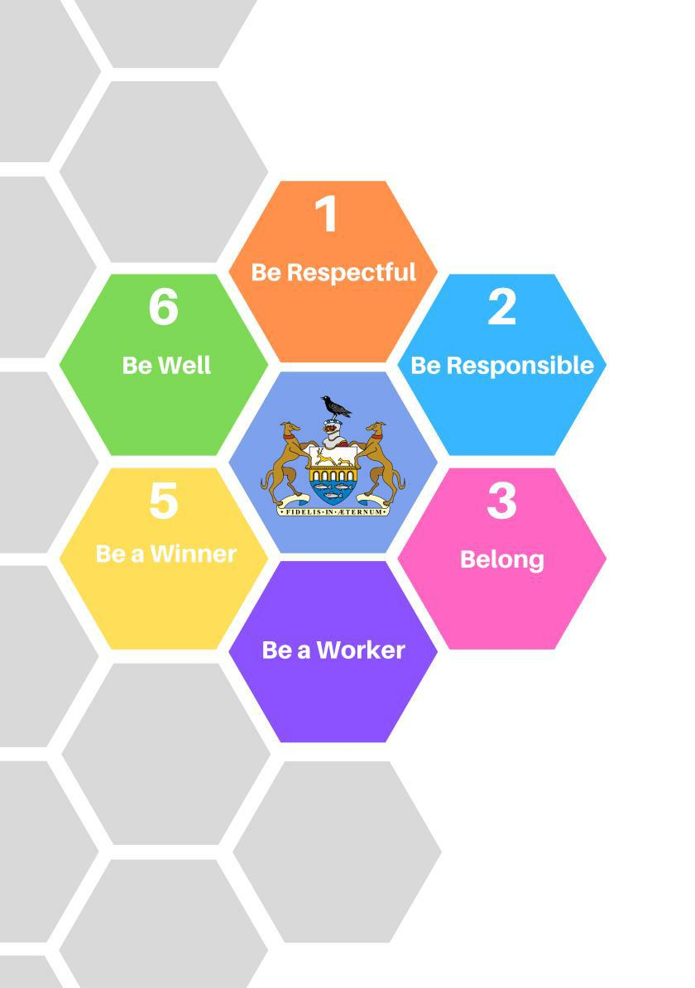

3.2 School Rules & Expectations

 | 1 |  |  | Be Respectful
 |  |  |  | This means | Because
● |  |  | That you respect the instruction of your |  | ● This helps everyone to be safe and succeed
 |  |  | teachers and all other school staff |  | in school
● |  |  | That you are courteous and respectful to |  | ● Everyone is entitled to this; you like to be
 |  |  | everyone in the school; |  | treated this way too;
● |  |  | That it applies especially when teachers and |  | ● It makes the outing more enjoyable for all.
 |  |  | other staff accompany you on trips
● |  |  | That you treat visitors to the school and |  | ● You like to be made welcome and to be
 |  |  | classroom with respect. |  | treated politely when you are a visitor.
● |  |  | That you have respect and consideration for |  | ● That is the right of every individual in the
 |  |  | other students. |  | school.
● |  |  | That you don't disturb the class; |  | ● It is unfair to others who wish to learn;
● |  |  | That you respect the property of others. |  | ● You would expect the same.

- Be Responsible
This means

- That you are tidy and careful with school property. Don’t break, damage or deface it.

- When using equipment or books, returning them tidily after class;

- You must not tamper with fire alarms/electrical equipment/sockets etc

- That you take good care of the locker which you have rented i.e. use it to store school books and school related equipment only. Other than when wearing it outside during break- times, your coat/jacket/non-school jumper must be kept in your locker during the school day

- That you take care of your schoolbag and other property;

- If you miss school you must bring in a note in your diary or a doctor's certificate;

- Lockers are only allowed to be used before first class, at break time, at lunch time and at the end of the school day.

- If you must leave school during the day, you get permission from Principal/ Deputy Principal and sign out, on returning to school you sign in;

- If you are unavoidably late, you bring a note signed by your parent or guardian;

Because

- Others have to use it and it is expensive to replace and repair it;
- This facilitates other users;

- It is an extremely dangerous offence as it endangers the safety of other students and staff and your own safety

- You have this locker on loan. A condition of this loan is that in the interests of student welfare and on health and safety grounds, your locker may be opened and its contents inspected by the Principal at any time without notice to you OR consent from you.

- It is yours and you are responsible for it.

- The school is entitled to an explanation from your parents or guardian; attendance matters; the law requires it.

- Going to lockers at other times impacts on your class time.

- The school is responsible for you during the day and therefore we must know where you are at all times.

- This is the courteous thing to do.

 | 3 |  |  | Belong
 |  |  |  | This means | Because
● |  |  | That you come to school in full uniform. |  | ● Wearing the full school uniform signifies
 |  |  | (See uniform policy: Section3.3) |  | that you a part of our school community.
● |  |  | Taking pride in the appearance of the |  | ● It is your social responsibility to do so.
 |  |  | school and avoiding litter;
● |  |  | Be helpful and treat others with |  | ● Like you, they are entitled to this;
 |  |  | good manners and respect;
● |  |  | That you bring your P. E. gear. |  | ● It allows you to take part in sports without
 |  |  |  |  | ruining your uniform.
● |  |  | Taking your break in the manner and area |  | ● This helps everybody to enjoy his/her break
 |  |  | specified; |  | and helps to keep the school clean and tidy.
● |  |  | That you get your diary signed weekly by |  | ● It lets your parent(s)/guardian see how you
 |  |  | your parent(s)/guardian and class teacher. |  | are getting on in your school life.
● |  |  | Look after each other |  | ● You all share the same school. We are one
 |  |  |  |  | community.
● |  |  | Follow the classroom rules set out by |  | ● These allow you to participate in your lessons
 |  |  | your teacher (see also Section 3.4) |  | in a positive way.
● |  |  | Follow the Corridor Charter (Section 3.5) |  | ● Doing so makes life pleasant and safe for
 |  |  |  |  | everyone in

 | 4 |  |  | Be a Worker
 |  |  |  | This means | Because
● |  |  | That you arrive at all classes on time. |  | ● It wastes your time, the teacher's time and
 |  |  |  |  | class time if you arrive late
● |  |  | That you come in properly prepared for |  | ● It wastes time if you haven't got them
 |  |  | your subjects. Have the proper books,
 |  |  | copies, pens, school diary etc.
● |  |  | That you bring any special equipment |  | ● It is impossible to do the subject without it.
 |  |  | needed, e.g. calculator etc.
● |  |  | That you carry your equipment in a |  | ● It prevents loss and keeps books from
 |  |  | schoolbag; |  | becoming tattered;
● |  |  | That you always do your homework each |  | ● It is a back up to the work done in class; it
 |  |  | night, written or oral; |  | helps you to easily recall material when
 |  |  |  |  | needed; it helps you to understand the
 |  |  |  |  | bigger picture in a subject
● |  |  | That you always carry your diary and take |  | ● It helps you remember what you have to
 |  |  | down your homework in it. |  | do.

- Be a Winner

This means

- That you come to school every day and arrive on time unless it is absolutely unavoidable

- That you bring your school bag into school each morning and take it home with you after school each afternoon;

- That you bring your bag and diary to every class.
- That you listen to your teachers;

Because
- Time missed is too hard to make up;

- It helps you to organize books needed for class and enables you to do your homework and study;

- This helps you be prepared for class and record your homework.
- The teacher is trying to help you;

- That you follow the classroom rules (see section 3.4);

- That you do your best to work, both in class and at your homework.

- They help everyone to learn to the best of their ability;

- By doing your best you can achieve your potential.

- Be Well

This means

- That you wear raingear coming to school in wet weather;

- Mobile phones or other electronic devices etc. must be switched off in class. (See Section 3.9)

- Don’t push or shove your way around
- No picking on or bullying others;
- No fighting;

- No smoking/Vaping in or near the school;

- That the possession, purchase, consumption of, or dealing in illegal or addictive substances is totally forbidden;

- The use of Aerosols, e.g. aerosol deodrants is not allowed

- Snacking is confined to break-time only, chewing gum is forbidden;

- That you do not drive/park your car or motorbike in the school grounds

- If you have any concern about yourself or another student talk to a member of staff or a member of the School Completion Team

Because

- It avoids sitting in wet clothes or missing class;

- They interfere with your concentration and can interfere with the progress of a lesson.

- This too can lead to accident or injury;
- This causes fear, hurt and misery;

- It can cause serious injury;
- It is illegal, unhealthy and dangerous

to do so; it contravenes the anti -smoking legislation enacted in 2004;

- It is illegal, unhealthy and dangerous to do so

- They cause breathing difficulties to those that have asthma or alergies

- It avoids interfering with learning and prevents litter;

- It is forbidden for health and safety reasons to do so

- By discussing the issue with someone else action can be taken.

3.3 Uniform Policy

The uniform identifies each student as a member of CTI Clonmel; it should be worn correctly and with pride. All clothing should be clean, neat and tidy. Parents and students are expected to ensure that the uniform is always prepared the night before for the following school day. This means ensuring that the uniform is clean and presentable.

Take pride in how you wear your school uniform. By doing so, you enhance your self-respect and dignity. You are reminded that your conduct on the way to and from school, when out at lunchtime and on school outings, when on work experience or when representing the school, is as important as within school. Any misbehaviour while in school uniform which brings the school into disrepute will be treated most seriously and will be acted upon by the Principal/Deputy Principal.
- The uniform must be worn in the school, to official school day trips and on formal school occasions.

- Full school uniform of Jumper, Shirt, Tie, Pants/Skirt and Black Shoes/ALL Black Runners must be worn daily.

- Changing out of uniform is not permitted unless authorised.

- White socks/white laces are not allowed.

- Where students are going on excursions where they are representing the school, (e.g. matches, debates, drama trips) students not in full uniform will not be permitted to join the group.

- Uniforms can be purchased at Uniform World, Ard na Gaoithe Business Park, Cashel Road, Clonmel, Co. Tipperary

- Students must change into P.E clothing for P.E class and change back into their school uniform immediately afterwards. (See section 3.8 for PE clothing policy)

- Jewellery is not permitted except for a single stud/sleeper worn in each ear to prevent piercing from closing and one plain finger ring only consistent with health and safety standards, required as the norm, in the school environment.

Raheen College School Uniform
 | Boys |  | Girls
● Liberty blue V-Neck Jumper with School |  | ● Liberty blue V-Neck Jumper with School
 | Crest |  | Crest
● | White shirt | ● | White shirt
● | Navy Trousers | ● Navy pleated knee length skirt or navy
 |  |  | trousers
● Navy and gold school tie |  | ● Navy and gold school tie
● Black Shoes/ALL Black Runners |  | ● | Black Shoes/max. heel height 1" (25
 |  |  | mm)/ALL Black Runners

Gaelcholaiste Cheitinn School Uniform
 | Boys |  | Girls
● Green V-Neck Jumper with School Crest |  | ● Green V-Neck Jumper with School Crest
● | White shirt | ● | White shirt
● | Black Trousers | ● Black pleated knee length skirt or black
 |  |  | trousers
● Black, green and gold school tie |  | ● Black green and gold school tie
● Black Shoes/ALL Black Runners |  | ● | Black Shoes/max. heel height 1" (25
 |  |  | mm)/ALL Black Runners

NOTE: Where correct uniform is not worn, the school will insist that he/she wears a uniform supplied by the school for that particular day. Persistent failure to wear full uniform, which includes black shoes, will incur the further sanction of detention. The school reserves the right to send students home who persistently fail to wear correct uniform.

3.4 Classroom Rules & Expectations

In the classroom you are expected to follow your teacher's instructions. This means:

 |  |  | ● Do not disturb the class. Allow everyone to learn.
 | Be Respectful |  | ● Listen ---- One voice only at a time. Wait your turn. Raise your hand to
 |  |  | speak.
 | Be Responsible |  | ● Always bring your bag and school diary to class.
 |  |  | ● Bring the books, copies, pens etc. that you require to each class every day
 | Belong |  | ● Keep the classroom tidy.
 |  |  | ● Follow the agreed class rules and consequences.
 |  |  | ● Be on time for class.
 | Be a Worker |  | ● Sit and remain seated in your place. Where you sit is decided by your
 |  |  | teacher.
 |  |  | ● Do your best to work both in class and at your homework.
 | Be a Winner |  | ● At the end of each class, push in your chair under the table and make sure
 |  |  | that you leave the place you occupied tidy. Line up and leave the room
 |  |  | quietly only when your teacher gives you permission.
 |  |  | ● Mobile phones or other electronic devices etc. must be switched off in
 | Be Well |  | class. See section
 |  |  | ● Follow all rules relating to Health and Safety

NOTE:

Each subject teacher will draw up a list of agreed class rules and consequences in line with the schools Code of Positive Behaviour with their students to ensure appropriate teaching and learning can take place.

In practical subject classrooms your teacher will insist upon other rules to ensure the safety of everybody and it is vital than you always comply fully and promptly with these.

3.5 Corridor Charter

 | Be Respectful |  | ● Co-operate with the directives of all the staff in the school.
 |  |  | ● Help visitors to the school to find their way.
 |  |  | ● Keep the corridors free of bags and personal belongings.
 | Be Responsible |  | ● Students should be aware of the presence, for Health and Safety reasons,
 |  |  | of CCTV on the school corridors and in the assembly area in Coláiste
 |  |  | Chluain Meala.
 | Belong |  | ● Use the litter bins-keep our school environment tidy, neat and clean.
 |  |  | ● Wait quietly in line before entering classrooms.
 | Be a Worker |  | ● Walk in an orderly way between rooms along specified routes;
 |  |  | ● Enter and exit the school through the doors designated for students.
 | Be a Winner |  | ● Have your bag and all equipment with you when entering and leaving class.
 |  |  | ● Always be courteous, considerate, caring and aware of others.
 |  |  | ● When recreation is taken indoors due to bad weather, avoid horseplay and
 | Be Well |  | excessive noise.
 |  |  | ● Be aware of the danger to others of bags held, without care, at shoulder
 |  |  | level.

3.6 Homework

Homework includes written work, oral work, reading, project work, study/revision of material taught in class each day, each week and each term. Students are advised to try to do their homework:

- At a fixed, definite time each day
- As soon as is realistically possible after arriving home from school.

- In a warm, well lit, quiet room, with no distractions from television, mobile phone, radio, internet, other people etc.
- On the night it is given

3.7 No Place for Bullying

Each student is entitled to an education free from fear and intimidation. Bullying, which is an act of aggression causing embarrassment, misery, physical or emotional hurt or discomfort to another person, is not tolerated in our school. CTI Clonmel holds it as a core value that each student has the fundamental right to be him/herself and the clear responsibility and obligation to treat others as s/he would wish to be treated.

If you are being bullied, physically, verbally or on-line or via your mobile phone, you must tell a teacher, an SNA, the Principal or Deputy-Principal or one of the SCP team and we will treat what you tell us in confidence. If you see another student being bullied, tell someone working in the school or on the SCP team. Be assured that the bully/bullies will be dealt with in accordance with the school's 'Policy on Bullying', a copy of which may be had on request from the School Principal's office.

3.8 Uniform for P.E or Activities

The uniform for PE/ Activities consists of:

- polo shirt/t-shirt
- plain black tracksuit bottoms/sports shorts
- runners/sport specific shoes and socks

The school uniform and other property should be labelled to help its recovery if lost

3.9 Mobile Phones/Electronic Devices

The points listed here aim to ensure that learning can take place without interruption from mobile phones and devices and that students and staff are protected from potential harassment or bullying.

- To assist the school in implementing this policy, parents/guardians are asked not to contact students directly by mobile phone at any time during the school day. Please call the school to speak with them.

- Students who need to contact home urgently, should request permission to contact home from the school phone.

- Mobile phones or other electronic devices etc. must be switched off in class.

- Mobile phones will be confiscated if used during class time and will be returned at the end of the school day.

- In appropriate use of any other electronic device not suitable to the school/classroom setting will result confiscation of the devices until the end of the week. Any other devices can only be collected by your parent/guardian at an earlier time if s/he calls to the school.

- *Repeated breach of this rule means that your parent/guardian will be told that you must leave your mobile phone/electronic device at home. This means that you will not be allowed to bring the device to school for the remainder of the term or school year.

- No photographs/recordings may be taken/made, while on the school premises or during school related activities. Using digital devices in such a way without permission is a serious infringement on the rights of others.

- Where the school is made aware of an incident where students use mobile phones/digital devices to bully others or to send offensive messages or calls, this will be investigated under our Anti-Bullying Policy and will also be dealt with under the Code of Positive Behaviour

- It should be noted that it is a criminal offence to use a mobile phone/digital device to menace, harass or offend another person. As such, the school may consider it appropriate to involve the Gardaí in such incidents.

- A copy of the schools Mobile Phone/Electronics Policy updated in 2018 may be had on request from the Principals office. Students and their Parents/Guardians agree to these terms when signing the enrolment form for the school/will be expected to sign their agreement to abide by the terms of this policy at the start of the school year.

4.0 Implementation of Consequences

The implementation of consequences works within a referral system in our school and is on a graduated basis.

Subject Teacher

Board of Management
Deputy Principal/Principal
Deans of Positive Behaviour/ Muinteoir i bhFeighil
Care & Discipline Committee
Class Tutor
Deputy

The Subject Teacher

● The Subject Teacher is the cornerstone of our disciplinary system. Each teacher shares, with other teachers, a common responsibility for implementing the Code of Behaviour within the school and the school grounds.

● S/he has the responsibility to establish a Classroom Behaviour Plan and teach students to follow that plan. S/he has the right to impose appropriate consequences.

● S/he also has the right to expect support from the school management and from parents in implementing the plan. The Behaviour Plan is based on the norms of good behaviour set out in the school's Code of Positive Behaviour and states in clear terms what is required of the student within the classroom.

● A Classroom Behaviour Plan should be clearly displayed in each classroom. Students will need to be reminded of the requirements of the plan at regular intervals through the school year.

● As the rules in a practical subject area will take account of the requirements of safety, they will obviously vary from those applying in a non-practical subject area

Consequences for Breaches of Code of Positive Behaviour

When a student infringes a classroom rule the teacher should respond immediately, using if necessary, one of the consequences available to him/her (see section 4.3).

Giving lines, extra homework or behavioural related essays are not regarded as appropriate consequences for breaches of the Code of Positive Behaviour on educational grounds. Students may not, under any circumstances be put outside the classroom door, unless the teacher can guarantee his/her supervision by another member of the teaching staff for the entire duration of his/her dismissal from the classroom.

Class Tutor
● Work with students is primarily in a pastoral care role.
● Consult with student's teachers, keep records of these consultations.
● Check School Journals and communicate via Journal with home.

● Investigate minor incidents, ascertain which rules are infringed. Establish and deal with the facts. Impose appropriate sanctions in line with the Code of Positive Behaviour Policy.

● Regularly check inputs and comments in Class Behaviour Book to fulfil their Pastoral Care role and to bring behavioural issues to the Pastoral Care/Discipline Committee.
● Consult with Discipline Co-ordinator, Deputy Principal, Principal when appropriate.

Discipline Committee/Pastoral Care Team

● Assess student behavioural issues raised through inputs and comments in Class Behaviour Books.

● Discuss items brought to the attention of the Committee by Tutors/Class Teachers ● Recommend appropriate behaviour management strategies and consequences for
reported maladaptive behaviours.

● Review student progress post.

● Review success or failure of implemented sanctions.
● Consult with Deans of Discipline, Deputy Principal, Principal where appropriate

Deans of Discipline / Múinteoir i bhFeighil
● To administer the On Report system.
● To track each student within the system.
● To maintain and file records of students who come within the ambit of the system.

● To liaise with staff, Principal and Deputy Principal, School Completion Programme and H.S.C.L.

● To oversee the rostering and implementation of the Detention system
● To prepare files and records for presentation to the Board of Management

Deputy Principal/Principal

● Consult with teachers
● Consult with Principal

● Meet with parents and keep then informed of any behavioural problems ● Withdraw students from class.
● Impose suspensions. Notify parents in writing. Notify Education Welfare Officer where applicable.
● Refer students for psychological or specialised help.
● Impose Permanent Card Sanction.
● Liaise with outside agencies e.g. Garda Siochana, Educational Welfare Officer

Principal

● The Principal has overall responsibility for the implementation of the Code of Behaviour within the school. In the event of gross misbehaviour, the Board of Management empowers the Principal to sanction immediate suspension of the student pending discussion with all parties concerned – Student, Parents/Guardians, Support Services.

4.1 Possible Responses to Positive Behaviour

Rewards

Raheen College and Gaelcholaiste Cheitinn values, acknowledges, recognises, encourages, affirms, rewards and validates students' good behaviour by, e.g. verbal praise to student, certificates, positive note/phone call to parents, positive reports to parents/guardians at parent teacher meetings, student awards, end of year awards, school trips.
 | Awards and Rewards |  | Encouragements and Acknowledgements
● | Student newsletter | ● Quiet work of praise from teacher/tutor
● | Parents’ Newsletter | ● | Postcard home
● | Website | ● Positive note in journal
● | Social Media | ● | Positive call/text home
● Students work exhibited around the school |  | ● Highlighting positives homework copy
● | PA Announcements | ● Give jobs/responsibilities to students
● | Assembly announcements | ● | Acknowledge efforts
● BOM Commendation awards during the |  | ● Thank students at the end of class
 | year
- End of Year Awards

4.2 Consequences Applying to Breaches of Our School's Code of Behaviour

The consequences focus on the unwanted behaviour of the student rather than on the student personally. Consequences are not intended to be punitive. They are scaled to match the misdemeanour. They enable students to experience the consequences of their misbehaviour and to make responsible and mature choices.

Consequences are as follows:
- Teacher led Consequences as listed in Section 4.3
- Mandatory Consequences as listed in Sections; 4.4, 5.0 & 6.0

4.3 Graduated System in Responding to Inappropriate Behaviour

Low Level inappropriate Behaviour – Subject teacher, Class Tutor and Discipline Pastoral Care Committee

 | Examples of Low Level Inappropriate |  | Sample Sanctions
 | Behaviour
● Tidying up before class is over |  | ● | Proximity of teacher
● Talking out of turn |  | ● | Quiet word/reminder
● | Not following instruction | ● | Change seating
● Distracting others in class |  | ● | Social skill reminder
● Inappropriate language or comments |  | ● | Signal/gesture/look
● Not being in correct uniform |  | ● Record misbehavior in students journal
● | Littering | ● | Humour
● Not having class materials/journal |  | ● Role model/practice what is expected
● Inappropriate behaviour on corridors
● | Chewing gum/sweets/drinks | ● | Work sheet
● Late to class; morning/afternoon |  | ● Short detention by subject teacher
● | No schoolbag/equipment
● Moving from designated seat
● Refusing to do classwork

Sample interventions/supports for low lever inappropriate behaviour.

- SEN supports
- Tutor supports
- Induction programme – 1st year students
- NBSS teacher
- HSCL
- SCP

During class if the student does not respond to the above sanctions and continues to repeat the behaviour, record an objective description of the behaviour/s in class behaviour book for Pastoral Care/Discipline weekly meeting.

Medium Level inappropriate Behaviour – Subject teacher, Class Tutor and Discipline Pastoral Care Committee

 | Examples of Medium Level Inappropriate |  |  |  | Sample Sanctions
 | Behaviour
● | Persisting not wearing school uniform |  |  | ● Continued application of low level
 |  |  |  |  | sanctions
● | Continued engagement in low level |  |  | ● | Short duration detention
 | behaviours following appropriate |  |  | ● Temporary withdrawal to another class by
 | sanctions/supports |  |  |  | agreement
● | Disruption of teaching and learning |  |  | ● | Confiscation of device
● | Persistent refusal to work |  |  | ● Phone call to the parent/guardian
● | Absent from class |  |  | ● Behaviour monitoring by On Report White
 |  |  |  |  | Card
● | Verbal and/or physical aggression |  |  | ● | Meeting with parent/guardian
● Unauthorised use of electronic
 | devices/phones
● Leaving class without permission
● | Bullying
● Persistent lateness to class, between classes
Sample interventions/supports for medium lever inappropriate behaviour.
● | SEN supports
● | Restorative approaches
● | Progress approaches
● | Student support services
● Student behavioural plan – Report Card
● | Parental Involvement
● | NBSS teacher
● | HSCL
● | SCP
● | SCP

The subject teacher consults with the Pastoral Care/Discipline team regarding the supports and interventions available. These interventions are designed to help the students develop skills that should enable them to engage with learning.

High Level inappropriate Behaviour – Subject teacher, Class Tutor and Discipline Pastoral Care Committee

 | Examples of High Level Inappropriate |  | Sample Sanctions
 | Behaviour
● | Persisting engagement in medium level | ● Continued application of medium level
 | inappropriate behaviour |  | Sanctions
● | Fighting | ● Progression through report card system via
● | Theft |  | inputs into behaviour book and pastoral
● | Throwing an object likely to cause injury |  | care/discipline committee, white cards,
● | Leaving school without permission |  | yellow cards, detention
● | Behaviour that constitutes significant threat | ● Direct referral to DP/P
 | to Health and Safety | ● | Suspension
● | Serious damage to property | ● Suspension meeting attended by
● | Verbal and/or physical aggression |  | parent/guardian, student, DP and P
● | Smoking, possessing alcohol and/or illicit | ● | Referral to BOM
 | Substances | ● Progression to Red Card, sanctioned/in
● | Sending/posting offensive or inappropriate |  | consultation with BOM
 | messages/images | ● | Expulsion
● | Unresolved, persistent bullying
Sample interventions/supports for medium lever inappropriate behaviour.
● | SEN supports
● | Restorative approaches
● | Progress approaches
● | Student support services
● Student behavioural plan – Behavioural Report Card
● | Parental Involvement
● | NBSS teacher
● | HSCL
● | SCP

The subject teacher consults with the Pastoral Care/Discipline team regarding the supports and interventions available. These interventions are designed to help the students develop skills that should enable them to engage with learning.

4.4 Detention

Detention takes place during the final 20 minutes of lunch time. Detention applies where: a pattern of lateness ensues.

Notice of such will be given by the Dean of Discipline.
- Students “On Report with Detention” fail to achieve the minimum score.
20 minutes at the end of lunchtime the following day.
- A pattern of lateness ensues as recorded in the Late Book.

- Teachers may assign and supervise a short detention for students due to breaches of the Code of Positive Behaviour. This detention is supervised by the teacher.

4.5 Lateness

When late, a student must report to the office where a late note, specifying student's name, class and extent of the lateness, is issued. Lateness is recorded in the Late Book. Students who develop a patter of lateness will be given detention (See Section 4.4) **Parents will be notified if a pattern of lateness persists.

5.0 On Report Card System

A progressive and positive approach operates to identify and deal with the maladaptive behaviours of students. Where a student infringes rules on a persistent basis, the "On Report" mechanism will apply.

The rationale for putting a student "On Report" is to monitor his/her behaviour and afford him/her the opportunity to reflect on this inappropriate behaviour, and to make the choice to behave in accordance with the School's Code of Behaviour. "On Report" is both a Pastoral Care and a corrective strategy. The student is provided with a card where behaviour is scored on a scale of 1 to 5, with a factual description of the behaviour, for each class period during the day, over a set period of days. An average daily score of 40 or over (On Mondays and Tuesday) and 35 or over (Wednesday, Thursday and Friday) indicates that the student clearly understands what is required of him/her and demonstrates his/her capacity to modify behaviour accordingly. A consistent score under the target suggests a maladaptive behavioural problem with its origins outside the school environment. Parental co-operation will then be required to work towards solving the problem.

School Completion team, the HSCL and, if warranted, TUSLA may be involved to help the student with his/her difficulties.

Students who continually display maladaptive behaviours despite the implementation of a report card students will move onto the next card on the 5 stage process.

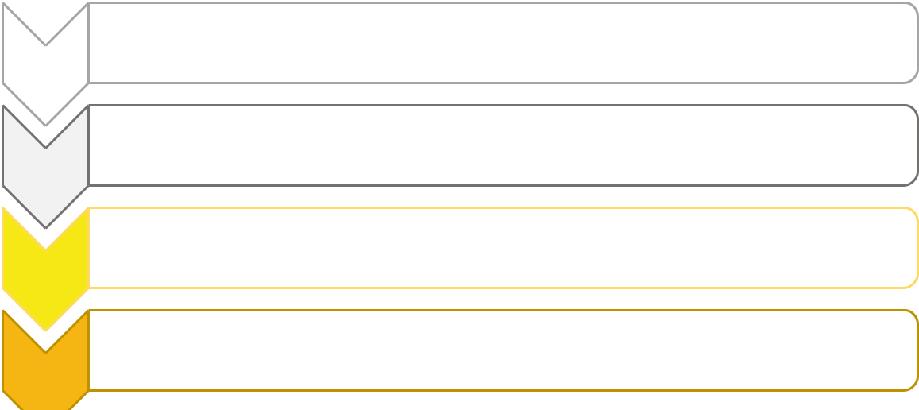
•White Card
- •5 School Days

•White Card with Detention
- •5 School Days

•Yellow Card
- •15 School Days

•Permanent Card (Red)
4
6.0 Mandatory Consequences

 | On Report
 |  | Imposed by: | Junior Cycle/Senior Cycle Dean of Discipline, Múinteoir i bhFeighil, Discipline
 |  |  | Committee/Pastoral Care Team, Deputy Principal, Principal, Board of
 |  |  | Management.
 |  | Why: | • Where a pattern of misbehaviour is recorded in Class Behaviour Book
 |  |  | this includes behaviours both in and out of the classroom.
 |  |  | • An incident in breach of the Code of Positive Behaviour requiring the
 |  |  | further monitoring of Student Behaviour.
 |  |  | • Where no significant improvement in behaviour is evident after a
 |  |  | student has been on a report card they move on to the next card.
 |  |  | • Any serious incident can result in a student being fast tracked to the
 |  |  | Permanent Card (Red).

How it works: The On Report Card system is a 5 step system (detailed below) with constant reviews in place.

- Students must achieve:
40/45 on Monday and Tuesday.
35/40 on Wednesday, Thursday and Friday.

- Students must present their On Report card at the end of each school day for review.

- Students who continue to display behavioural issues while on report or afterwards move on to the next stage of the On Report System following review.

- On completion of any stage of the On Report Card, where the student has no behavioural issues, he/she comes off the On Report Card system but maintains their place within it. i.e having completed the white card, if later in the year another incident occurs the student will be placed onto the next card

- Any comment recorded on the back of a Report Card for misbehaviour can result in a deduction of up to 5 marks.

- Students who are On Report with Detention and fail to reach the target scores are liable to a 20 minute detention at the end of lunch time the following day.

- The loss of a Report Card is a most serious matter. Such a loss

may mean moving on to the next sanction stage.

- Students who are placed on a Permanent Card must present before the Board of Management to discuss their future in the school.

 |  | 1. | White Card | 5 school days
 |  | 2. | White Card with Detention | 5 school days
 |  | 3. | Yellow Card | 15 school days
 |  | 4. | Permanent Report Card (Red) - (Rare Cases) | Permanent

On Report – Permanent Report Card (Red)

 | Imposed by: | Deputy Principal, Principal, Board of Management.
 | Why: | • Where no significant improvement in behaviour is evident after a
 |  | student has been on all other report cards they move on to the
 |  | Permanent Report card (red).
 |  | • Any serious incident can result in a student being fast tracked to the
 |  | Final stage of the discipline process and/or Board of Management.

How it works: The Permanent Report Card is the final stage in the school’s Discipline Structure

- Students must achieve:
40/45 on Monday and Tuesday.
35/40 on Wednesday, Thursday and Friday.

- Where a student is placed on a Red Card, it is mandatory that he/she appears with his/her parent(s)/guardian(s) at the next Board of Management (BOM) meeting. This is at the BOM’s request. It is to afford Board members an insight into the student’s behavioural issues and to allow them to emphasise to the student and his/her parent(s)/guardian(s) the seriousness of the student’s situation and the consequences of any further serious breaches of the Code of Positive Behaviour.

- Students must present their On Report card at the end of each school day for review to the Deans of Discipline.

- Students who continue to display behavioural issues while on the Permanent Report Card must to present before the Board of Management having exhausted all disciplinary procedures.

- Any comment recorded on the back of a Report Card for misbehaviour can result in a deduction of up to 5 marks.

- Students who are On Report with Detention and fail to reach the target scores are liable to a 20 minute detention at the end of lunch time the following day.

- The loss of a Report Card is a most serious matter. As a consequence, the student will have to repeat the day or week as required.
- Where a student incurs the sanction of a Red Card, this is reviewed by the Pastoral Care/Disciplinary committee weekly.

Sent Home
 | Imposed by: | Deputy Principal/Principal
 |  | • Where a student breaches the Code of Behaviour and where that
Why:

breach is deemed to be serious, he/she may be sent home, at the discretion of the Principal/Deputy Principal, for the remainder of the school day on which the breach occurs. The Principal/Deputy Principal will base this decision on Health and Safety grounds, to prevent an incident escalating further or perhaps to allow the student time out to cool off when emotions are running high or where the breach is disrupting the learning of others.

- Student persistently fails to wear school uniform How it works: Parents/Guardians contacted

- Student is removed from the school pending further discussion with parents/guardian around the situation.

 | Suspension
 |  | Imposed by: | Deputy Principal/Principal/Board of Management.
 |  | Why: | • A one day suspension for truancy on leaving the school grounds
 |  |  | without permission.

- When the graduated steps in our list of sanctions have been tried and have failed to modify behaviours which interfere with the learning process of others.

- Abusive attitude towards staff including use of foul/inappropriate language

• Immediate suspension where the continued presence of the student in the school at the time would represent a serious threat to the safety of students or staff of the school or any other person.

• Interfering with/Damaging fire alarm/fire equipment/other health and safety equipment

• Behaviour that has had a seriously detrimental effect on the education of other students

How it works: A suspension not exceeding three days for one off incidents, continual breaches of the code of behaviour.

- The nature of the complaint is clarified with the student and parent/guardian. Student and Parent/Guardian are given an opportunity to respond before any decision to suspend is imposed.

- In the case of immediate suspensions, parent/guardian is notified, and

arrangements made with him/her for the student to be collected, the school having regard to its duty of care for the student. In no circumstances is a student sent home from school without first notifying parents/guardian.

- Parents notified in writing.

- E.W.O notified (where necessary)

- Reported to the Board of Management

- Student returns to school on set date accompanied by parent(s)/guardian(s).

- Student goes onto the On Report system.

- Suspensions no longer than 3 days may be improved with consent of Chairperson of Board of Management.
- Suspensions longer than 5 days adhere to the National Education Welfare Board Guidelines (Chapter 10 & 11)

 | Expulsion
 |  |  | Imposed by: |  | Board of Management
 |  |  | Why: |  | • Automatically applied where drug dealing/supplying/ sharing takes
 |  |  |  |  | place within the school and/or within the school’s grounds.
 |  |  |  |  | • Actual violence or physical/sexual assault on or threat of same to
 |  |  |  |  | another student or staff member
 |  |  |  |  | • Student is responsible for serious damage/vandalism to property
 |  |  |  |  | • Exhausted all other discipline proceedures within the school.
 |  |  |  |  | • Brings the school into disrepute via Social Media or through other
 |  |  |  |  | forms
 |  |  |  |  | • Student’s behaviour is a persistent cause of significant disruption to
 |  |  |  |  | the learning of others or to the teaching process
 |  |  |  |  | • The student’s continued presence in the school constitutes a real and
 |  |  |  |  | significant threat to his or her own safety or that of others in the school community
 |  |  |  |  | • A detailed investigation carried out under the direction of the
 |  |  | How it works:

Principal

• Student and parent(s)/guardian(s) are notified in writing of the nature of the complaint, thus ensuring that parents have records of the allegation against the student and the investigation itself and written notice of the grounds on which the BOM is being asked to consider expulsion

• Student and parent/guardian are given an opportunity to respond before any decision to expel is imposed. A recommendation is made to the BOM by the Principal regarding proposed expulsion, giving BOM the same comprehensive records as have been given to parents.

• Parents are notified, giving them adequate notice and time to prepare, of the date of hearing by the BOM. They are invited to the hearing and advised of their right to make a written or oral submission to the hearing by the BOM.

• On deciding to expel, the BOM notifies the EWO in writing of its opinion and the reasons for its opinion. The student cannot be expelled before the passage of 20 school days from the date on which the EWO receives this written notification. The student remains suspended from the school for the duration of these 20 school days.

• When the 20 school days period has ended the BOM formally confirms the decision to expel/following alternative recommendations from the EWO makes its decision. Parent(s)/Guardian(s) are notified in writing of the decision.

• If expulsion is to proceed, parent(s)/guardian(s) and the student are told about the right to appeal to the E.T.B. and the DES and supplied with the standard form on which to lodge an appeal.

• A formal record is made of the decision to expel the student.

• The decision to expel is notified to the EWO in accordance with legalisation. The school’s decisions are made and implemented in line with Section 23 of the Education (Welfare) Act 2000. The rules of natural justice are adhered to. All expulsions are reported to the Educational Welfare Officer as required by law.

7.0 Our Contract with You

CTI Clonmel, Raheen College and Gaelcholáiste Chéitinn undertakes to provide a service to the student in the way of education, sport, extra- curricular activities etc. provided that the student presents him/herself in a state to receive it; this means appropriate behaviour, satisfactory punctuality, compliance with the school dress code, committed application to school work, homework and study and general readiness to learn.

The BOM, Staff, Parents and Pupils of CTI Clonmel acknowledge and accept their collective responsibility to act in a manner that promotes a positive, mutually respectful and tolerant school climate in accordance with the values espoused in staff, parent and student charters.

Attendance at the school implies that the parents/guardians and the student have been provided with a copy of the Code of Positive Behaviour, have confirmed in writing that the Code of Positive Behaviour is acceptable to them and that they will make every eﬀort to ensure compliance with such Code by the student. This written confirmation is the contract between the parents/guardian and the school.

Central Technical Institute reserves the right to modify, add to or alter details of this Code of Positive Behaviour at short notice.

