Raheen College &
Gaelcholáiste Chéitinn
Child Protection Policy

The Board of Management recognises that child protection and welfare considerations permeate all aspects of school life and must be reflected in all of the school's policies, practices and activities. Accordingly, in accordance with the requirements of the Department of Education and Skills' Child Protection Procedures for Primary and Post Primary Schools, the Board of Management of Raheen College & Gaelcholáiste Chéitinn has agreed the following Child Protection Policy:

- The Board of Management has adopted and will implement fully and without modification the Department's Child Protection Procedures for Primary and Post Primary Schools as part of this overall child protection policy.

- The Designated Liaison Person (DLP) is John McCarthy

- The Deputy Designated Liaison Person is Tina Kennedy

- In its policies, practices and activities, Raheen College & Gaelcholáiste Chéitinn will adhere to the following principles of best practice in child protection and welfare:
The school will
  - Recognise that the protection and welfare of children is of paramount importance, regardless of all other considerations:
  - Fully cooperate with the relevant statutory authorities in relation to child protection and welfare matters
  - Adopt safe practices to minimise the possibility of harm or accidents happening to children and protect workers from the necessity to take unnecessary risks that may leave themselves open to accusations of abuse or neglect:
  - . Develop a practice of openness with parents and encourage parental involvement in the education of their children: and
  - Fully respect confidentiality requirements in dealing with child protection matters.

The school will also adhere to the above principles in relation to any adult pupil with a special vulnerability.

- School policies and services in Raheen College & Gaelcholáiste Chéitinn which are particularly relevant to Child Protection are as follows:

  - Code of Behaviour
  - Drugs policy
  - Anti-bullying policy
  - Attendance policy
  - Health and Safety Policy

- HSCL
- School Completion Programme
- Guidance Policy
- Breakfast Club
- Lunch Provision in the school
- Homework Club
- Counselling
- SNA's
- LT. Policy
- Pastoral Care
- Student Council
- Mall Charter
- Critical Incident Management Policy
- Policy on dealing with the aftermath of a suicide or suspected suicide
- As per staff handbook in the "Guidelines for Teachers Working in Raheen College and Gaelcholaiste Cheitinn" full cognisance is taken of implementation of Child Protection Guidelines with regard to school outings, one-to-one interaction with students, transportation of students etc
- Where a student is on work experience, he/she is visited by the school staff to ensure that his/her welfare is being protected.
- Students are supervised by school staff from 8am to 5pm daily

- This policy has been made available to school personnel and the Parents' Association and is readily accessible to parents on request. A copy of this policy will be made available to the Department and the patron if requested.
- This policy will be received by the Board of Management once in every school year.
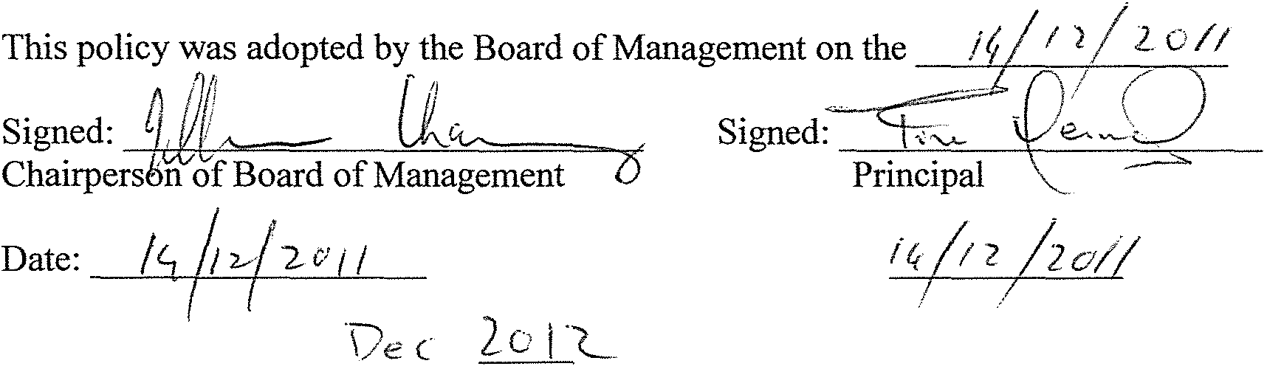
Date:
Date of next review:

